|  |  |
| --- | --- |
| Project Name : | Inventory and Supply chain Application |
| Document Prepared By and Date: | Alauddin (25th Oct 2018) |
| Project Proposed Timeline | Start: 27th Oct To 10th Nov 2018 |
| Project Actual Timeline |  |
|  |  |

**WCL procurement process:**

**1. Requisition generate:**

a. From site office or head office.

b. Keep Option for both fill format and scan of a hard copy.

c. Option for upload file, picture etc.

d. The requisition must be filled with following data:

i. Present stock in accurate number or estimate quantity in case of difficult to

measure the quantity accurately.

ii. Total requisition quantity with breakdown quantity and time in case of multiple

delivery.

iii. Material name, size, code (if any) shall be very specific in name.

iv. The approved brand shall be mentioned clearly for every material.

**2. Requisition approval:**

a. Shall come to authorized person in Engineering department to approve.

b. Authorized person can approve, edit or reject the requisition.

c. He can add or upload more file or picture or put comments during authorization.

d. If rejected, this notification shall go to original requester as ‘for his information’.

**3. Procurement process:**

a. The approved requisition will come to Supply chain department.

b. Procurement shall collect quotations, finalize price or will be omitted if the price

considered as finalized earlier.

c. Procurement will prepare a fund/ budget requirement based on finalized price or

estimated price and payment method e.g. cash, CDC, PDC, LC, BG etc.

d. The fund raising form shall goes to concern authority and either approve, reject or

modify with comment.

e. Then the fund raising approval shall come back procurement with notification to

account department.

f. A budget requirement with payment option shall be generated and goes to account

department while the fund is approved by authority so that they can start their

formalities like cheque preparation, BG preparation, cash readiness etc.

g. Procurement will generate a work order and will send it to supplier/ vendor etc. the

work order will be given as hard copy from offline generation but will generate in the

process as WORK ORDER GIVEN.

h. A work order delivery notification shall be sent to site office, engineering and account

department as FOR THEIR INFORMATION.

**4. Materials delivery:**

a. Supplier will delivery materials and will give challan either full as in work order or partial

as instructed by procurement or site office.

b. Site office store shall receive the materials with proper process like gate entry, input

MRR etc.

**5. Billing process and audit:**

a. Supplier/ vendor shall submit the bill with necessary document to procurement.

b. Procurement will check the bill and add all other necessary documents with the bill to

submit to audit.

c. Audit will review the bill and may ask to engineering or supply chain for any queries to

approve the bill to pass to accounts.

**Report requirement for Supply chain Application:**

1.**Price, cost and rate analysis:**  
a.Rate of same material for different suppliers for a specific time period.  
b.Rate of same material for a specific supplier for a specific time period.  
c.Comparison of rate for different supplier for same material.  
d.Comparison of rate for different brand for same material.  
e.Total cost (based on work order) for same materials for a specific project for a specific time period.  
f.Total cost (based on work order) for all materials for a specific project for a specific time period.  
g.Total cost (based on work order) for all materials for a specific ‘material group’ for a specific project for a specific time period.  
h.Total cost (based on work order) for different suppliers for all materials for a specific project.  
i.e, f, g and h will be same with change of ‘All projecs’ instead of ‘specific project’.  
j.Total project cost till date based on issued work order.

**2.Price, cost and rate analysis: All from 1 (a to j) with change of service instead of materials.**

**3.Time analysis:**a.Time (durations) data and analysis report as follows:  
i.Time from requisition float to approval.  
ii.Time from requisition approval to budget approval.  
iii.Time from budget approval to Work order issue for non RFQ materials, items etc.  
iv.Time from budget approval to Work order issue for RFQ materials, items etc.  
v.Time from Work order issue to materials delivery for RFQ and non RFQ items.  
vi.Time from Material receives to Challan and MRR released from sites.  
vii.Time from Bill received to bill forwarding to Audit.  
viii.Time from Bill received by Audit to Bill approved by Audit.  
ix.All the above should be done for both individual project and all projects.

**PROJECT UNDERSTANDING**

**PROJECT ESTIMATION**

|  |  |  |  |  |
| --- | --- | --- | --- | --- |
| **ID** | **Phase** | **Task** | **Release** | **Proposed Hours** |
| 1 | Analysis |  | Week1 | 56 |
| 2 | DB Design |  | Week2 | 40 |
| 3 | Requisition | Requisition generate | 7 |
| 4 | Requisition approval | Week3 | 16 |
| 5 | Procurement | Collect Quotation | 7 |
| 6 | Budget | 50 |
| 7 | Work Order | Week4 | 9 |
| 8 | Materials | Materials delivery | 12 |
| 9 | Billing | Billing process and audit | 24 |
| 10 | Acl Role | Acl role implementation | Week5 | 32 |
| 11 | Wastage | Wastage Inventory | 5 |
| 12 | Alert | Min stock alert | 2 |
| 13 | Movement | Moving inventory from one project to other project | 16 |
| 14 | Report | Rate of same material for different suppliers for a specific time period | Week6 | 4 |
| 15 | Rate of same material for a specific supplier for a specific time period. | 2 |
| 16 | Comparison of rate for different supplier for same material. | 5 |
| 17 | Comparison of rate for different brand for same material. | 2 |
| 18 | Total cost (based on work order) for same materials for a specific project for a specific time period. | 3 |
| 19 | Total cost (based on work order) for all materials for a specific project for a specific time period. | 5 |
| 20 | Total cost (based on work order) for all materials for a specific ‘material group’ for a specific project for a specific time period. | 2 |
| 21 | Total cost (based on work order) for different suppliers for all materials for a specific project. | 2 |
| 22 | 16, 17, 18 and 19 will be same with change of ‘All projects’ instead of ‘specific project’. | 16 |
| 23 | Total project cost till date based on issued work order. | 6 |
| 24 | Price, cost and rate analysis: All from (12-21) with change of service instead of materials. | Week7 | 64 |
| 25 | Time from requisition float to approval. | 5 |
| 26 | Time from requisition approval to budget approval. | 3 |
| 27 | Time from budget approval to Work order issue for non RFQ materials, items etc. | 3 |
| 28 | Time from budget approval to Work order issue for RFQ materials, items etc. | 3 |
| 29 | Time from Work order issue to materials delivery for RFQ and non RFQ items. | 3 |
| 30 | Time from Material receives to Challan and MRR released from sites. | 3 |
| 31 | Time from Bill received to bill forwarding to Audit. | 3 |
| 32 | Time from Bill received by Audit to Bill approved by Audit. | 3 |
| 33 | All the above should be done for both individual project and all projects. | 3 |
| 34 | All (23-32)should be done for both individual project and all projects. | Week8 | 40 |
| 35 |  | Testing and Bugfixing | 56 |
| 36 |  | Security | 24 |
| 37 |  | Total |  | 536 |

**UI Design:**

**4.1. Supplier List**

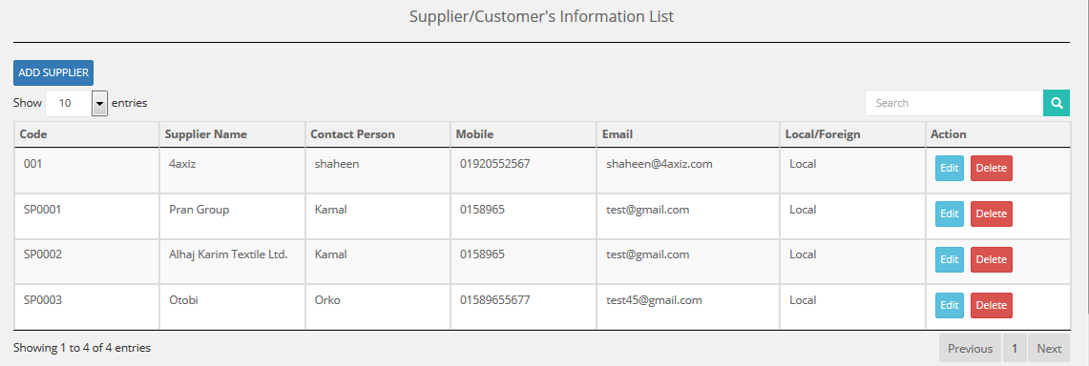

**4.2. Supplier Information Entry Form**

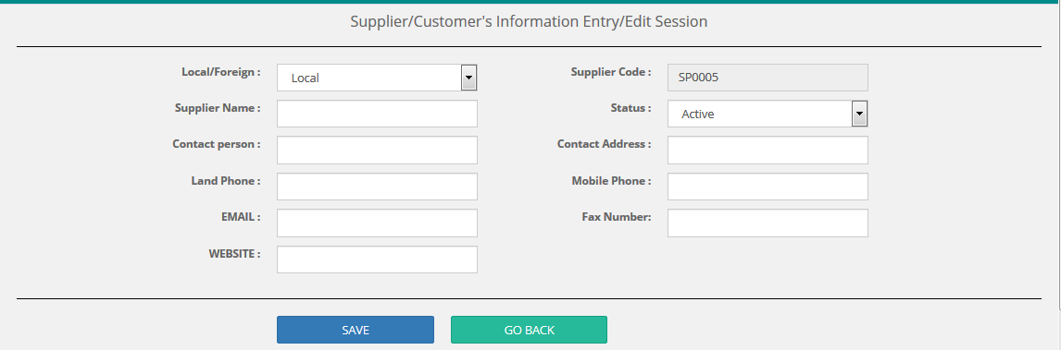

**4.3. Item List**

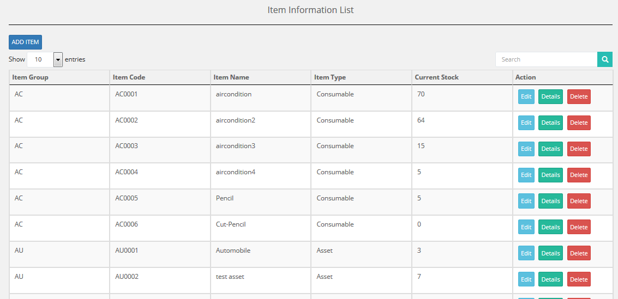

**4.4. Item Information List Entry Form**

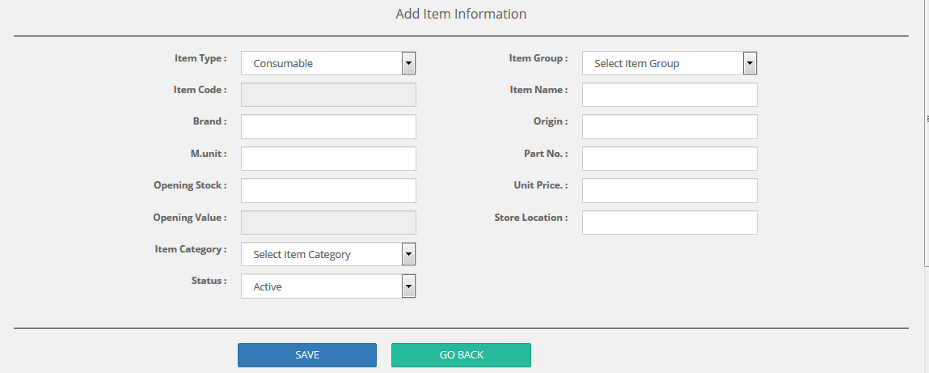

**4.5.Material Indent Or Requisition List**

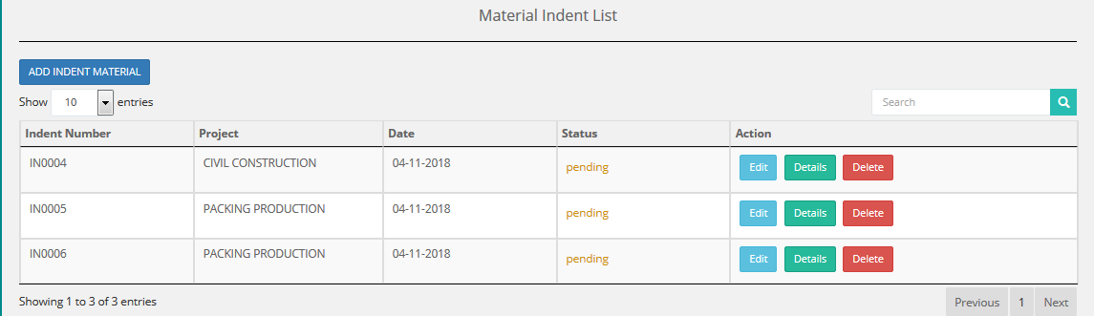

**4.6. Material Indent Or Requisition Entry Form**

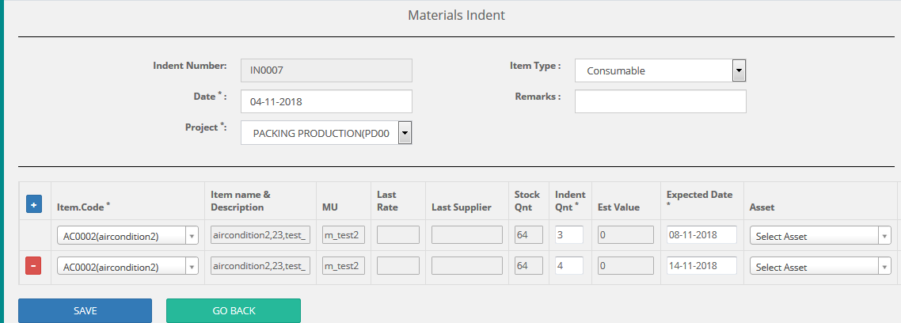

**4.7. Budget List**

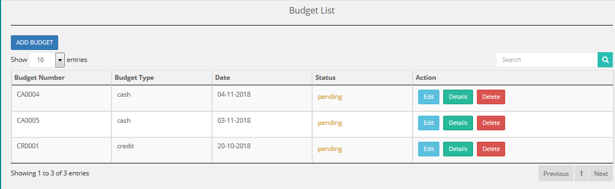

**4.8. Budget Entry Form**

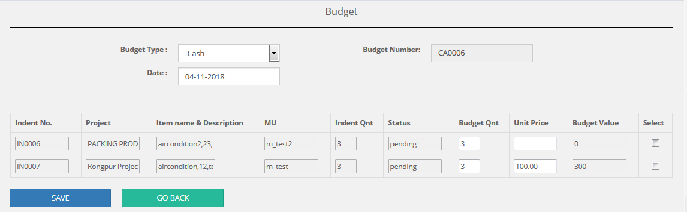

**4.8. Receive List**

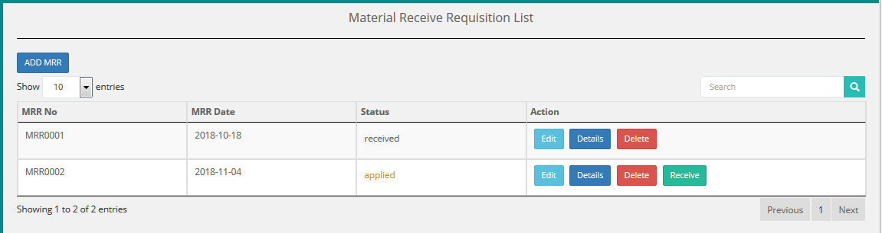

**4.8. Receive Entry Form**

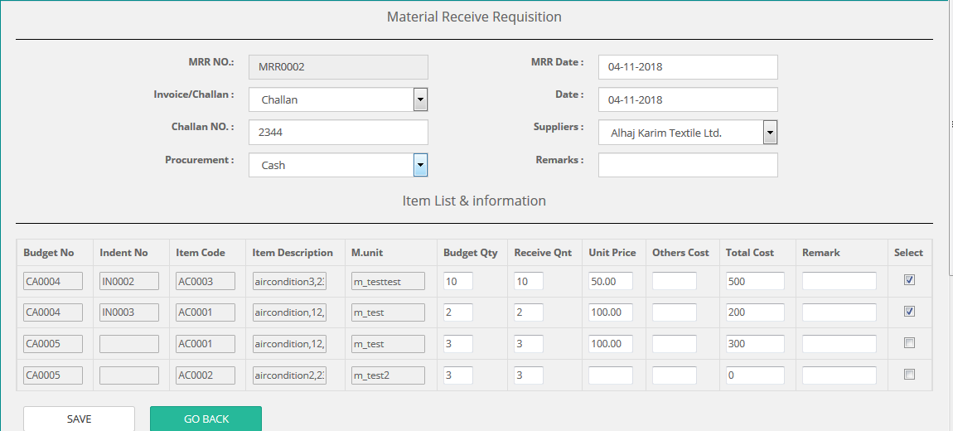

**4.8. Material Issue List**

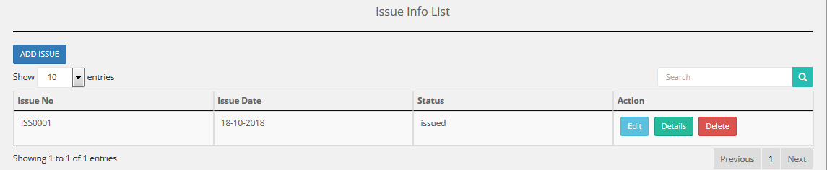

**4.8. Material Issue Entry Form**

